**POORNIMA AYURVEDIC MEDICAL COLLEGE, HOSPITAL & RESEARCH CENTRE, RAICHUR**

**PAIN ASSESSMENT SHEET**

|  |
| --- |
| Patient Name: UHID No:  Age: Diagnosis:  Sex: OP/IP No: |

|  |  |
| --- | --- |
| INITIAL PAIN ASSESSMENT | |
| Pain Location |  |
| Intensity |  |
| Character |  |
| Frequency |  |
| Duration |  |
| Referral or Radiating pain |  |
| Alleviating & aggravating factor |  |
| Present Pain Management Regimen & effectiveness |  |

Date:

Pain Assessment, Management & Monitoring Chart

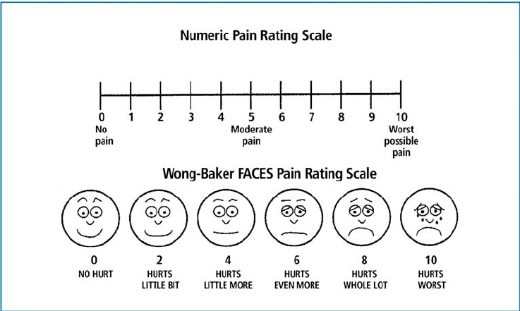

Reassessment

|  |  |  |  |  |  |  |
| --- | --- | --- | --- | --- | --- | --- |
| Date & Time | Pain Score | Intervention  (Medication & Therapy) | Outcome | Side effects (if any) | Advices | Staff name & sign |
|  |  |  |  |  |  |  |